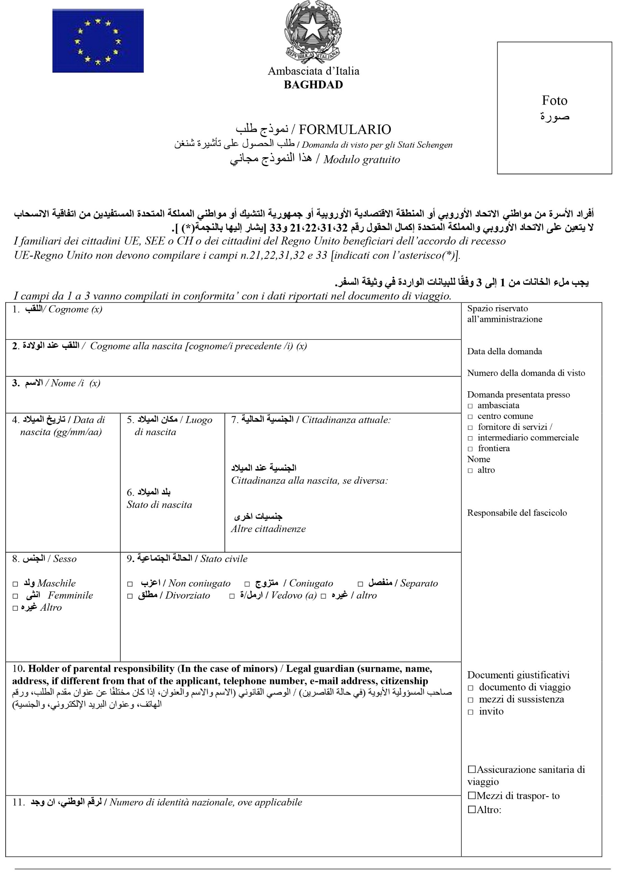

ALJASSANI

ALJASSANI
TABAREK RADHI FADHIL

IRAQI
BAGHDAD
09-07-1996
IRAQI
IRAQ

✓
✓

199631324126
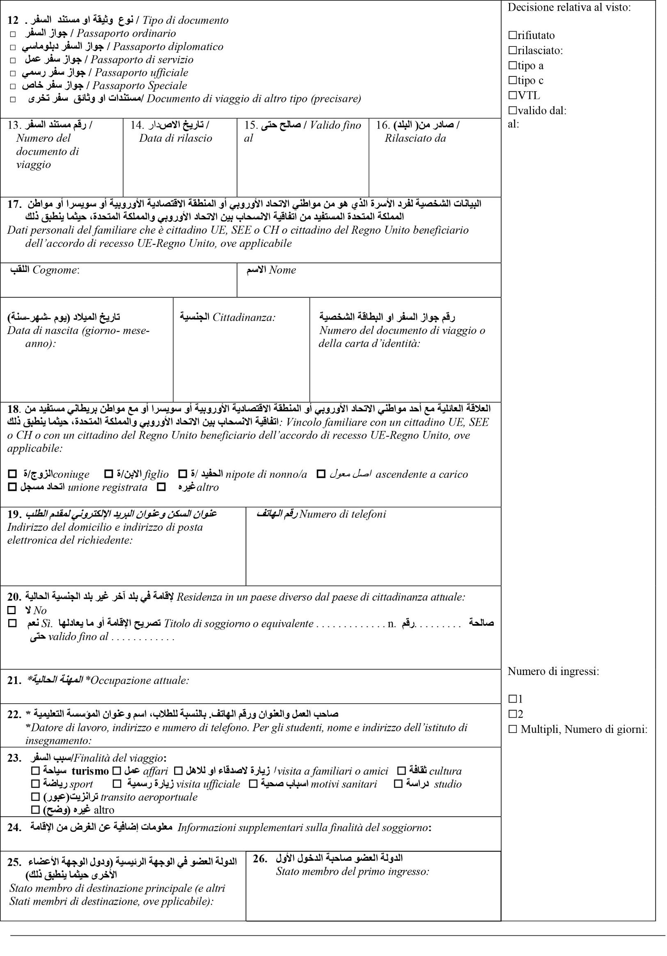
✓

A15022676
IRAQ
12-02-2027
13-02-2019

DIST. 627, ST. 30, HOUSE 1/6, BAGHDAD- IRAQ. E: AHHM.ALI96@GMAIL.COM
+964 7724873848
✓

MEDICAL DOCTOR

SHAHID MOHAMMED BAQIR AL-HAKIM HOSPITAL, BAGHDAD- IRAQ. TEL: 07733244000. EMAIL: MARTY.MBBAGHDAD@GMAIL.COM
✓

I INTEND TO TRAVEL FOR A HOLIDAY TRIP WITH MY SPOUSE.

ITALY
ITALY

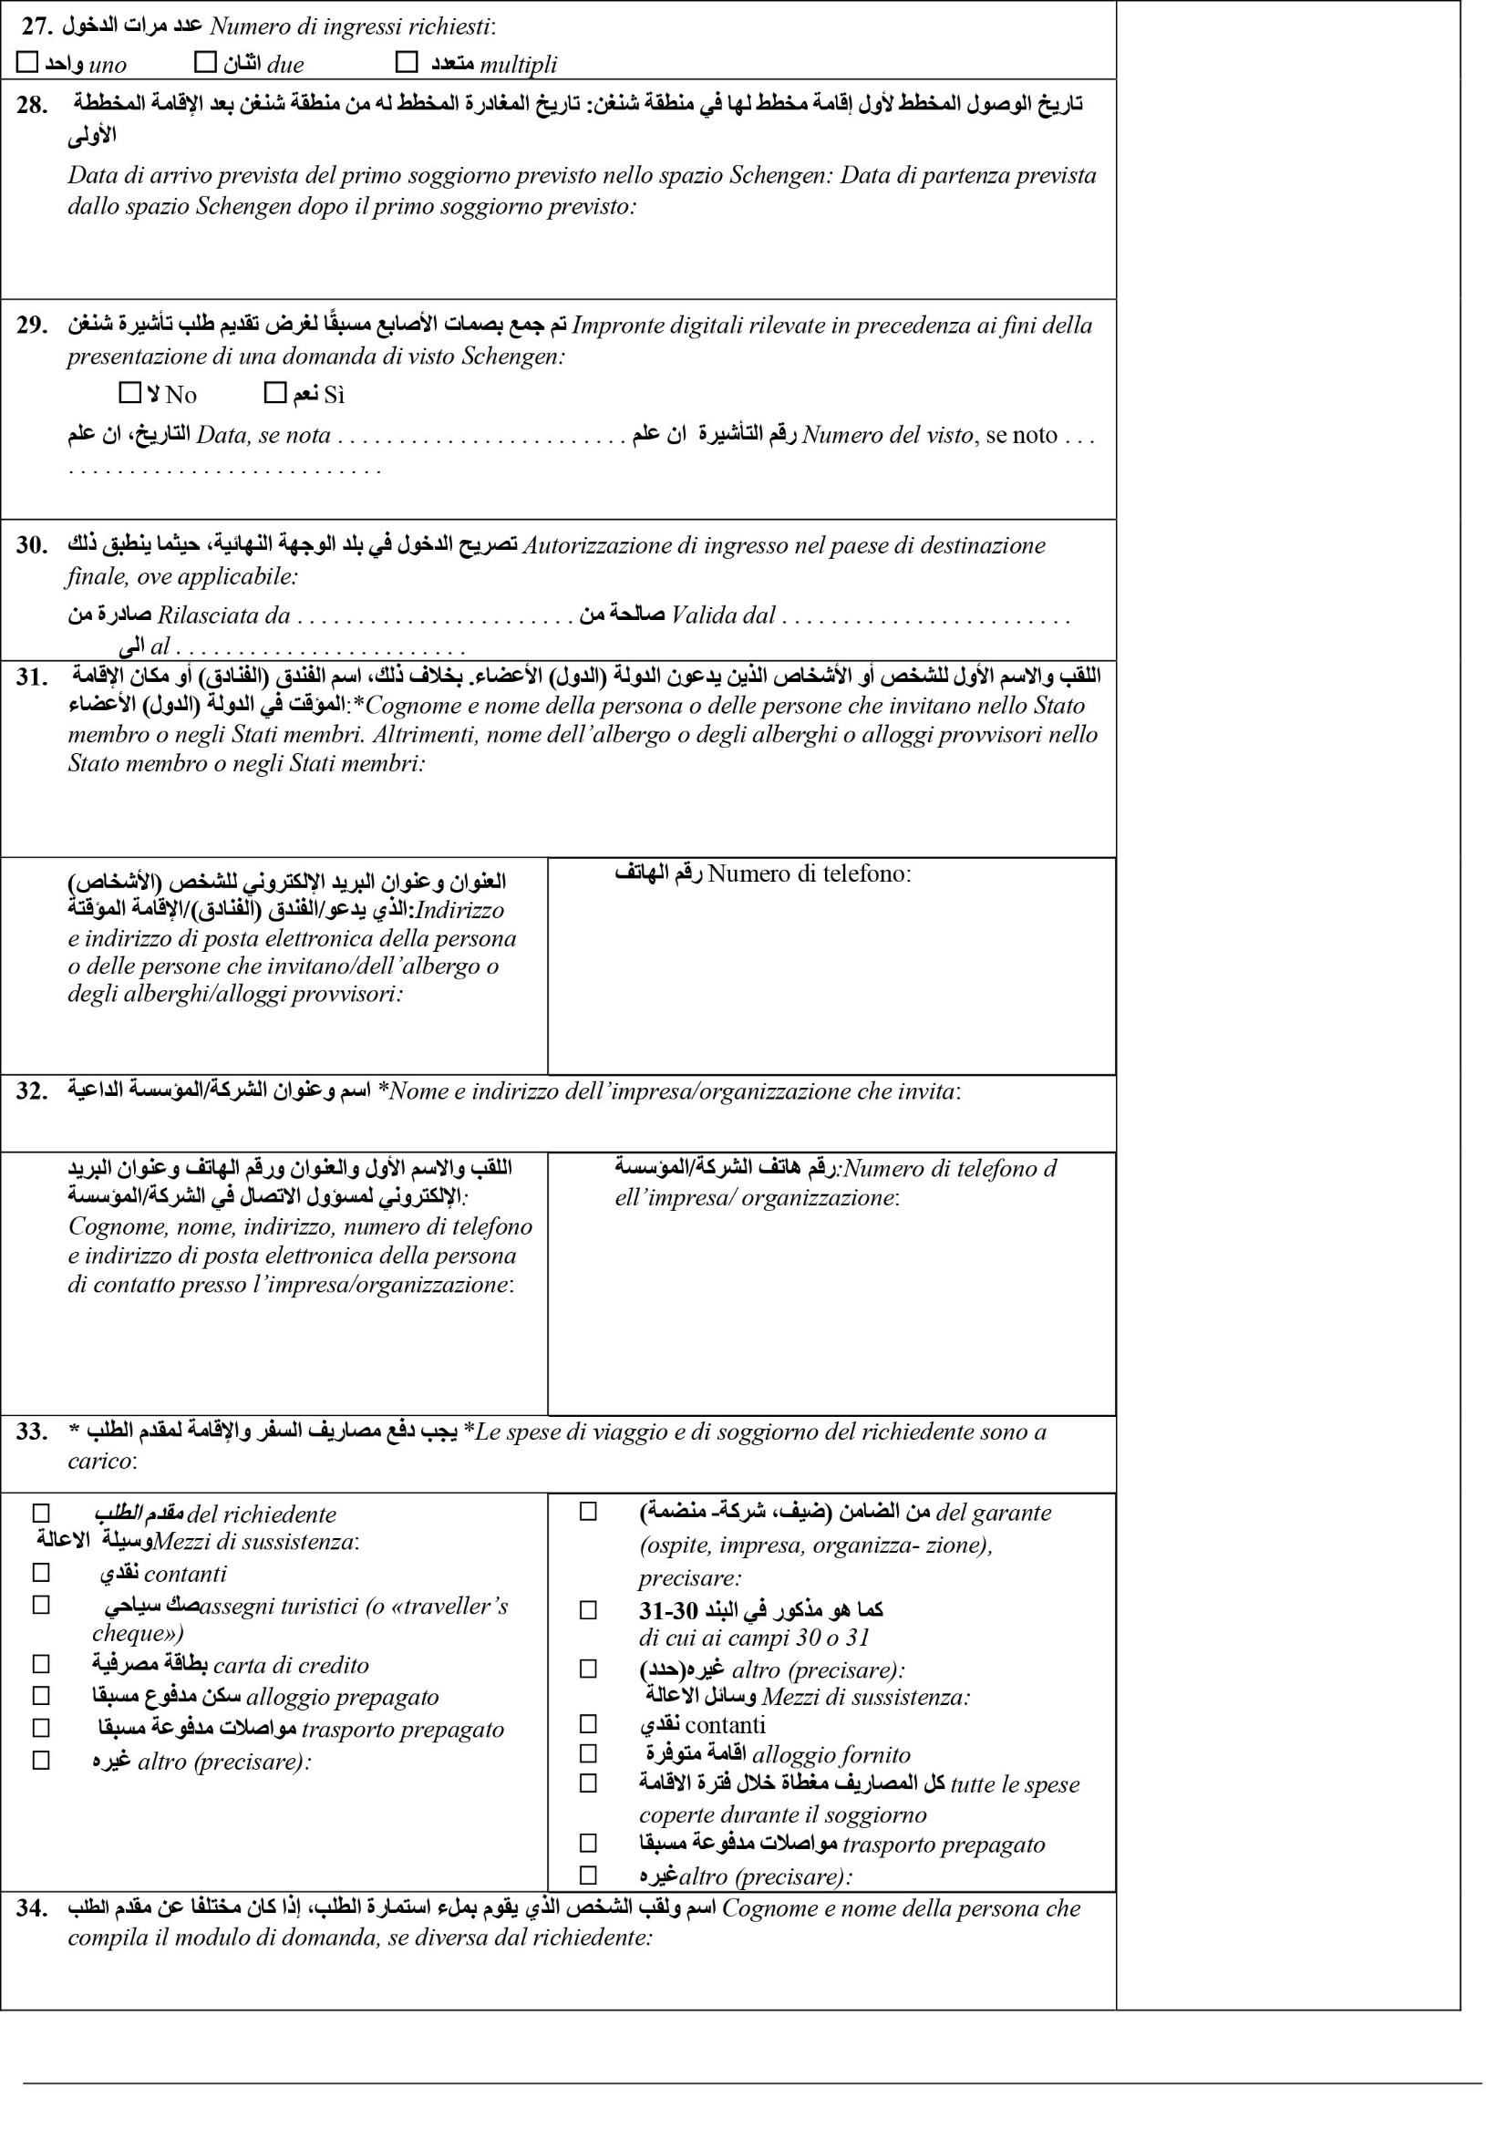
✓

05-09-2025
13-09-2025
✓

Inner House apartment rome

+39 06 8666 0616
Via Milazzo, 11, 00185 Roma RM, Italy

✓
✓

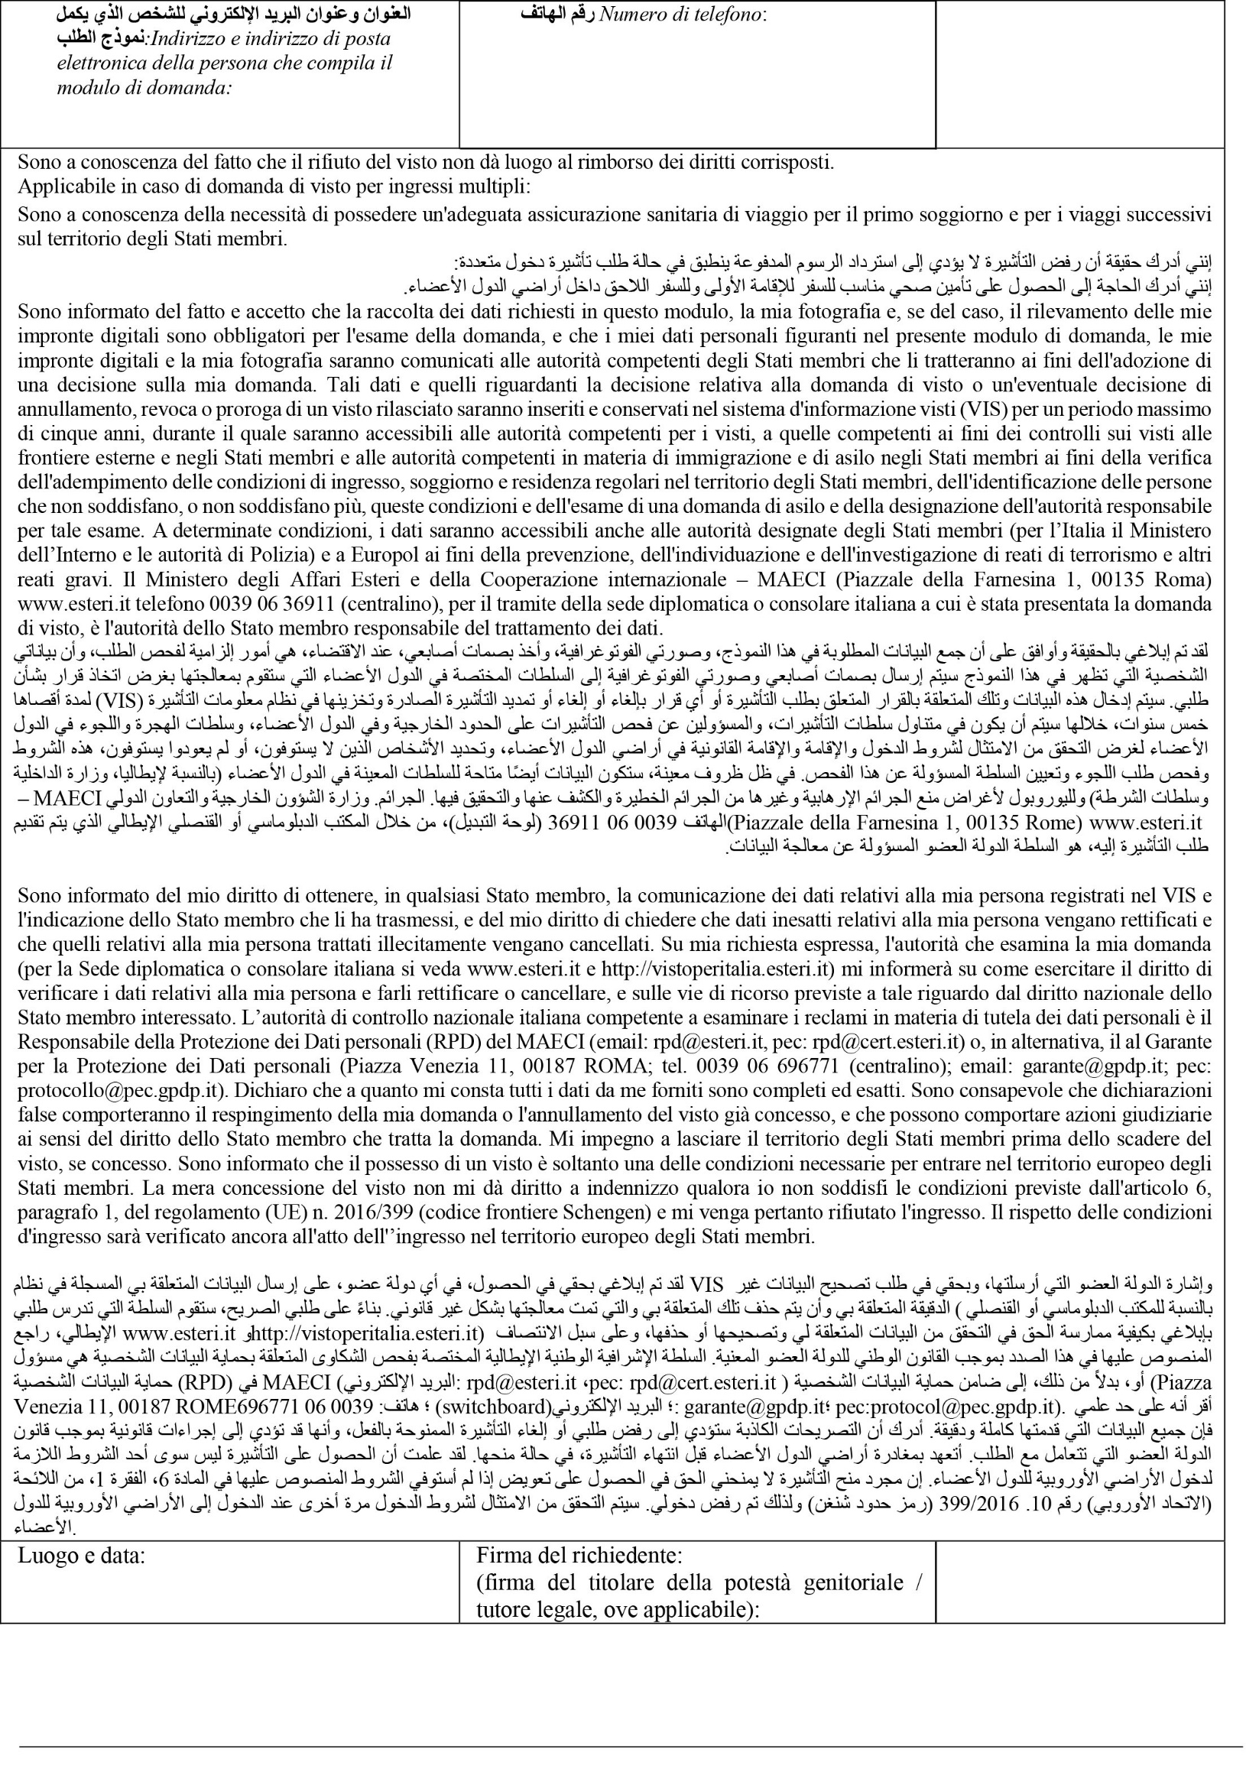
baghdad, iraq

